Ideation Phase
Define the Problem Statements

Date | 31 January 2026
Team ID | LTVIP2026TMIDS24918
Project Name | Visualizing Housing Market Trends: An Analysis of Sale Prices and Features using Tableau
Maximum Marks | 2 Marks

Customer Problem Statement Template:

Create a problem statement to understand your customer's point of view. The Customer Problem Statement template helps you focus on what matters to create experiences people will love. A well-articulated customer problem statement allows you and your team to find the ideal solution for the challenges your customers face. Throughout the process, you’ll also be able to empathize with your customers, which helps you better understand how they perceive your product or service.
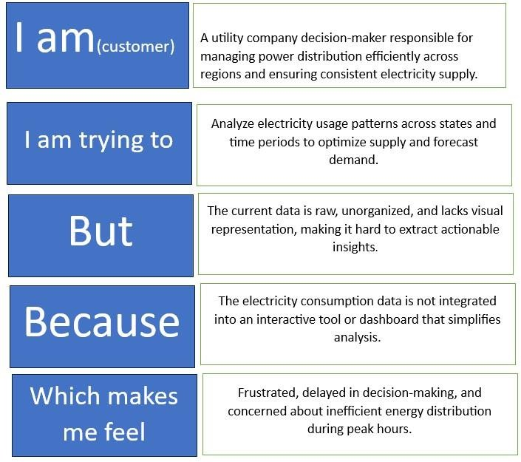
The data isn’t structured into dashboards and lacks filters or segmentation for exploring renovation status, house features, or trends over time.
The housing dataset is large, inconsistent, and lacks interactive visuals, making it difficult to find patterns quickly and draw useful insights.
The housing dataset is large, inconsistent, and lacks interactive visuals, making it difficult to find patterns quickly and draw useful insights.
Understand how factors like renovation age, number of bedrooms, and bathrooms influence sales prices and housing trends using data analysis.
A real estate analyst at ABC Company, responsible for identifying pricing patterns and helping teams make data-driven housing strategy decisions.

Example :

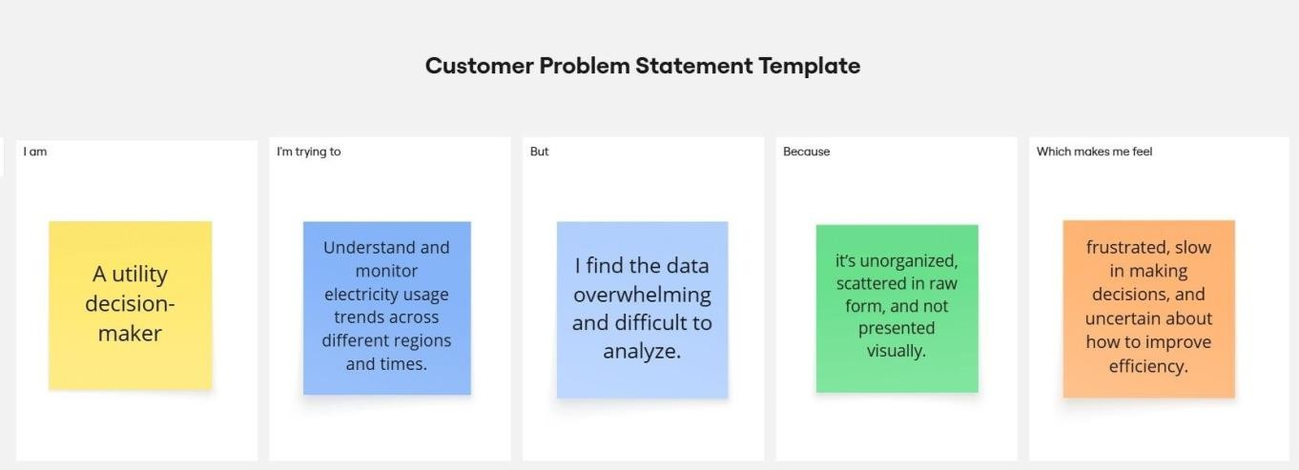

Problem Statement (PS)

Problem Statement (PS) | I am... | I’m trying  to... | But... | Because... | Which makes me feel...
PS-1 | A real estate analyst at ABC  Company | identify factors affecting house prices and features | the dataset is large and hard to interpret | it lacks clear visualizations and segmentation | overwhelmed and unsure where to focus
PS-2 | A marketing team member planning pricing strategies | understand sales trends by renovation and house features | data is spread across multiple tables with limited insights | it hasn’t been structured for easy storytelling | confused and unable to create compelling campaigns
PS-3 | A senior executive at ABC  Company | make data- driven decisions to stay  competitive | the current reports are too generic and outdated | they don’t highlight key market patterns or actionable  KPIs | disconnected from real-time housing market insights
PS-4 | A Tableau dashboard user in the company | interactively explore housing trends | existing charts are static and not interactive | filters and dynamic views are missing | restricted and unable to drill into important data

